**CR(Computed Radiography)   
IP (Image Plate) Test Report**

**FUJI(ST-VI) / AGFA (CAWO DIGIT BL)**

Thermal and chemical analysis for this report was performed by a professional analysis agency,   
and comparison tests for X-ray images were performed at Digiray.



DIGIRAY.Corp. 825ho, 142, Ilsan-ro, Ilsandong-gu, Goyang-si, Gyeonggi-do, Republic of Korea   
TEL: +82(0)3180787784 BUSINESS NUMBER: 314-81-93106

Copyright DIGIRAY.Corp. All rights reserved.

**Contents**

**1.** **Image Plate specification** 3

**1.1 FUJI (ST-VI) specification** 3

**1.2 AGFA (DIGIT BL) specification** 3

**1.3 DIGIRAY FUJI (ST-VI) / AGFA (DIGIT BL) Image Plate Cassette** 4

**2. Thermal Properties and Chemical Analysis** 5

**2.1 Analysis Institution** 5

**2.2 Analysis item** 5

**2.3 Analysis Equipment & Test Conditions** 5

**2.4 SEM / EDS** 5

**3. X-ray Image** 8

# **Image Plate specification**

## **1.1 FUJI (ST-VI) specification**

FCR Imaging Plate for general purpose

14" x 17" (35.4 x 43.2 cm)

14" x 14" (35.4 x 35.4 cm)

10" x 12" (25.7 x 30.5 cm)

8" x 10" (20.3 x 25.4 cm)

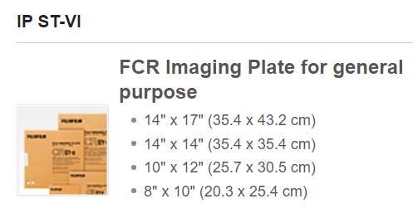

## **1.2 AGFA (DIGIT BL) specification**

CAWO Image Plate sensitivity and sharpness at low dose

1. Standard Sizes

18 x 24 cm, 18 x 43 cm, 20 x 40 cm, 24 x 30 cm,

35 x 35 cm (14 x 14”), 35 x 43 cm (14 x 17”),

15 x 30 cm, 8 x 10”, 10 x 12”

Other sizes on request.

1. Phosphor composition

BaSrFBrl:Eu

1. Image retention

Two hours after exposure 70 % of the stored energy is still present with no visible loss of information upon readout. Image retention still exceeds 45 % after 24 hours. Readout is recommended within 1 hour after exposure.

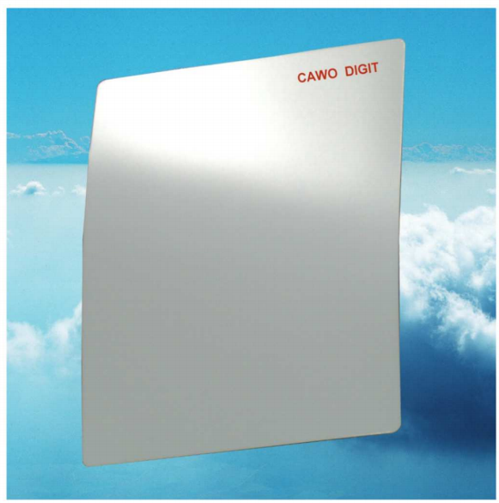

## **1.3 DIGIRAY FUJI (ST-VI) / AGFA (DIGIT BL) Image Plate Cassette**

|  |  |
| --- | --- |
| **FUJI(ST-VI)** | **AGFA(DIGIT BL)** |
|  |  |
| **3543 IP cassette** | **3543 IP cassette** |
|  |  |
| **2430 IP cassette** | **2430 IP cassette** |
|  |  |
| **1824 IP cassette** | **1824 IP cassette** |

# **2. Thermal Properties and Chemical Analysis**

## **2.1 Analysis Institution**

: Polymer Total Analysis Technology Researcher  59, Oncheon-ro, Yuseong-gu, Daejeon, Republic of Korea TEL. 042-826-4377 FAX. 042-826-4378

## **2.2 Analysis item**

: FT-IR, Raman, WD-XRF, SEM/EDS

## **2.3 Analysis Equipment & Test Conditions**

**FT-IR (Nicolet 6700) - Test Mode**: ATR , Wave Number : 4000 ~ 650cm-1 , Number of Scan : 32/4 , Detector : MCTA

**SEM/EDS (Quanta 250 FEG/Apollo XP) - High Vacuum Mode , Coating Material**: Au

**Raman Spectrometer (DXR 3xi) - Laser**: 532nm , Wave Number : 3400 ~ 50 cm-1 , Number of Scan : 30

**WD-XRF (ZETIUM) - Mode**: High Vac 37mm , S/W : Quantification Analysis , Detector : Flow & Scintillation

Five products of each vendor were sampled and measured. It was confirmed that the thermal and chemical properties of the samples for each company were the same.

## **2.4 SEM / EDS**

|  |  |  |
| --- | --- | --- |
| **FUJI (ST-VI)** | | **AGFA (DIGIT BL)** |
| |  |  |  | | --- | --- | --- | | **Element** | **Wt%** | **Wt% Sigma** | | C | 27.35 | 0.34 | | O | 4.16 | 0.22 | | F | 3.38 | 0.21 | | Zn | 1.82 | 0.20 | | Br | 15.45 | 0.25 | | I | 4.37 | 0.23 | | Ba | 43.47 | 0.38 | | Total: | 100.00 |  | | | |  |  |  | | --- | --- | --- | | **Element** | **Wt%** | **Wt% Sigma** | | C | 23.25 | 0.45 | | F | 1.72 | 0.25 | | Br | 16.62 | 0.36 | | I | 6.72 | 0.36 | | Ba | 51.69 | 0.52 | | Total: | 100.00 |  | |
| **Electron Image** | | **Electron Image** |
|  | |  |
| **EDS Layered Image** | | **EDS Layered Image** |
|  |  | |
| **C K series** | **C K series** | |
|  |  | |
| **O K series** | **O K series** | |
|  |  | |
| **F K series** | **F K series** | |
|  |  | |
| **Zn L series** |  | |
|  |  | |
| **Br L series** | **Br L series** | |
|  |  | |
| **I L series** | **I L series** | |
|  |  | |
| **Ba L series** | **Ba L series** | |

# **3. X-ray Image**

**3.1 X-ray Equipment & Test Conditions**

**3.2 X-ray Images**

Five products of each vendor were sampled and measured. It was confirmed that the image properties of the samples for each company were the same.